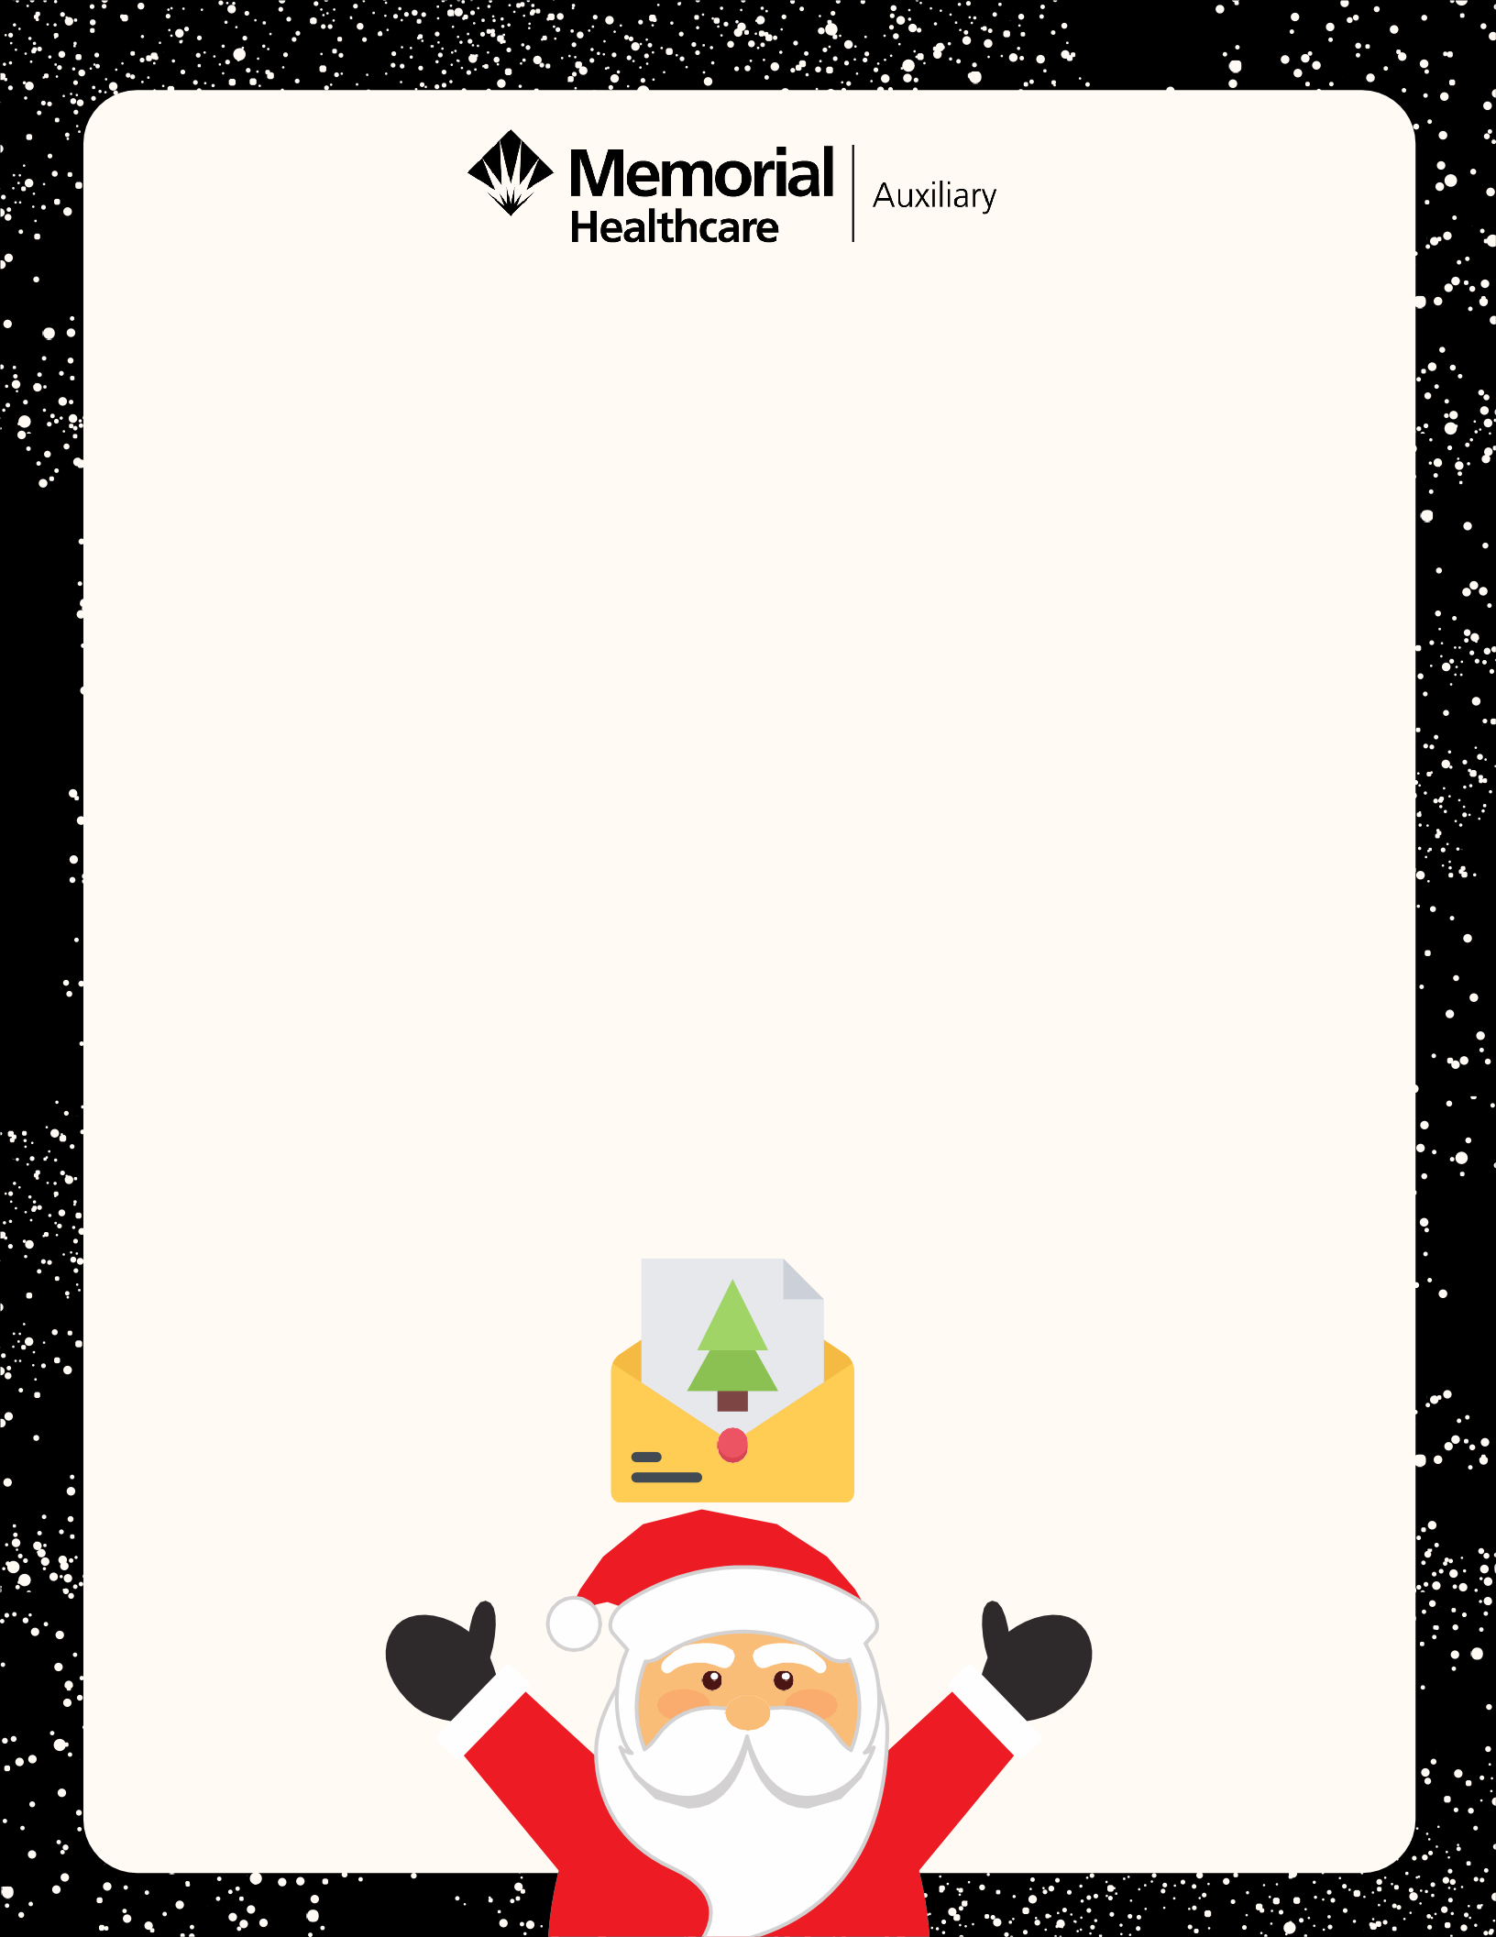

LETTERS
FROM SANTA
Order a personalized handwritten letter from Santa to your child or children!
To request a letter from Santa, please send the completed form on the back with payment to
Memorial Healthcare Auxiliary,
826 W. King Street, Owosso, MI 48867

If you have questions or would like to pay by
credit card or payroll deduction, please call
(989) 729-4675 or email MHCauxiliary@gmail.com
Requests must by postmarked by December 3!

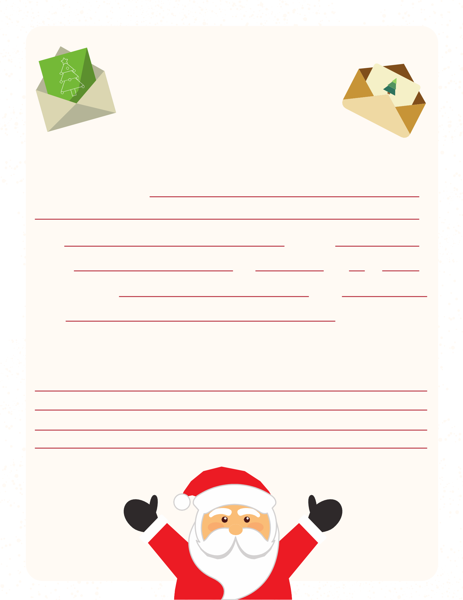LETTERS
FROM SANTA
Order Form

Child/Children’s Names

Age(s) Gender(s)

Address City State Zip Parent(s) Name(s) Phone
Email

Personal Information (What are your child's likes? What grade are they in? Do they have pets? Is there something you would like me to encourage them to do (clean their room or be kind to your sibling)?

Letter(s) will arrive between December 13-21!

